

[Document title]

[Document subtitle]

NAME: Muhammad Noman ijaz

ROLL NO:21F-9513

SECTION:BS(SE)B

DATE OF SUBMISSION : 27 SEPTEMBER Till 9:00PM

Assignment: ICT

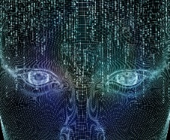 WHAT IS COMPUTER SCIENCE?

## Computer science is the study of computers and computational systems. Unlike electrical and computer engineers computer scientists deal mostly with software and software system;this includes their theory,design,devolpment,and application .principal areas of study within computer science include artificial intelligence ,computer systems and networks,security,database systems human computer interaction

## It also include vision and graphics ,numerical analysis , programming languages ,software engineering ,bioinformatics and also it include theory of computing .although how to program is essential to the study of computer science it is the only one element of the field . computer scientists design and analyze the algorithms to solve programs and study the performance of computer software and hardware. Programmers also solve different type of problems with the help of different tools like flowchart and pseudocode.

## The problems that computer scientists encounter range from the abstract determining what problems can be solved with computers and the complexity of the algorithms that solve them to the tangible designing applications that perform well on handheld devices that are easy to use and that uphold security measures .computer science is the emerging subject now a days .computer science is very interesting subject but programing is to difficult .

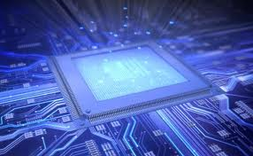

WEDNESDAY SHEDULE

|  |  |  |  |  |  |  |
| --- | --- | --- | --- | --- | --- | --- |
| 8:45to 10:10 | 10:15to11:40 | 11:45to 1:10 | 1:10to1:45 | 1:45to2:45 | 2:45to 4:40 |  |
| Programming fundamental | English lecture | Ps | break | ICT Auditorium | ICT Lab |  |